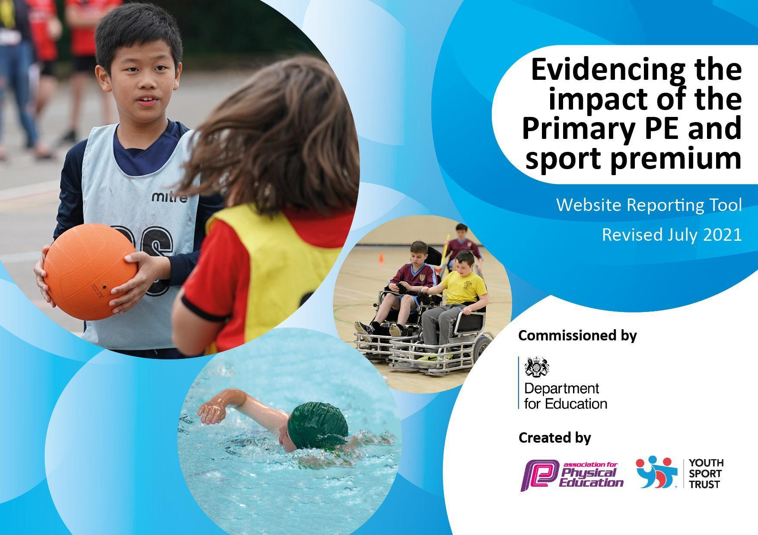

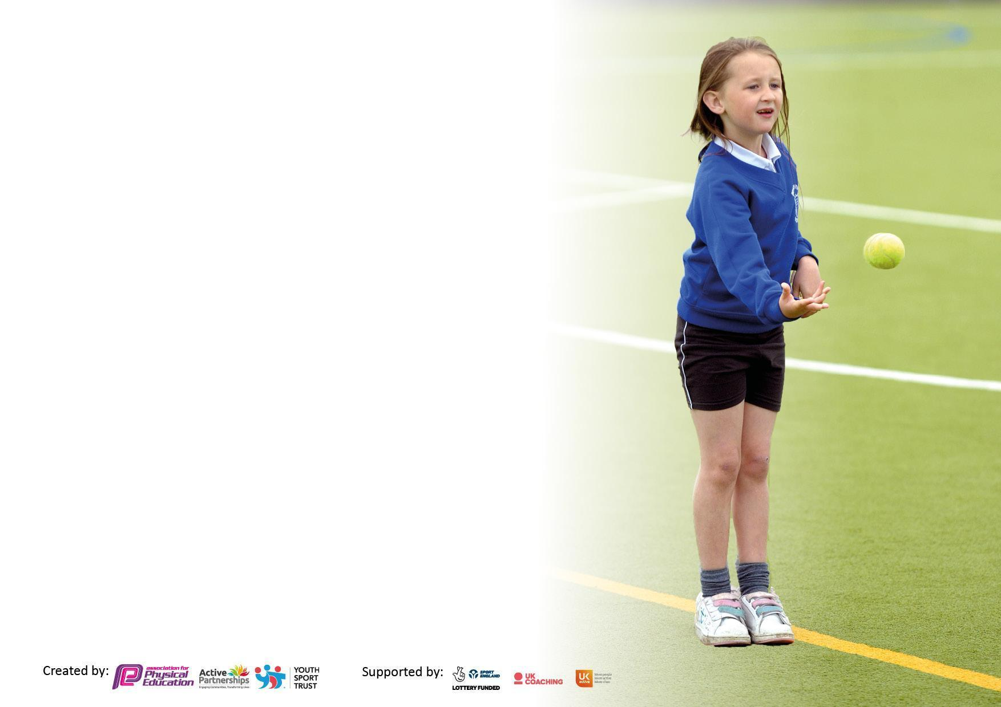

It is important that your grant is used effectively and based on school need. The Education Inspection Framework makes clear there will be a focus on **‘whether leaders and those responsible for governors all understand their respective roles and perform these in a way that enhances the effectiveness of the school’**.

Under the Quality of Education Ofsted inspectors consider:

**Intent** - Curriculum design, coverage and appropriateness

**Implementation** - Curriculum delivery, Teaching (pedagogy) and Assessment

**Impact** - Attainment and progress

To assist schools with common transferable language this template has been developed to utilise the same three headings which should make your plans easily transferable between working documents.

Schools must use the funding to make **additional and sustainable** improvements to the quality of Physical Education, School Sport and Physical Activity (PESSPA) they offer. This means that you should use the Primary PE and sport premium to:

* Develop or add to the PESSPA activities that your school already offer
* Build capacity and capability within the school to ensure that improvements made now will benefit pupils joining the school in future years
* The Primary PE and sport premium should not be used to fund capital spend projects; the school’s budget should fund these.

Pleasevisitgov.ukfortherevisedDfEguidanceincludingthe5keyindicatorsacrosswhichschoolsshoulddemonstrate animprovement.Thisdocumentwillhelpyoutoreviewyourprovisionandtoreportyourspend.DfEencouragesschools to use this template as an effective way of meeting the reporting requirements of the Primary PE and sport premium.

We recommend you start by reflecting on the impact of current provision and reviewing the previous spend.

Schools are required to publish details of how they spend this funding, including any under-spend from 2022/2023, as well as on the impact it has on pupils’ PE and sport participation and attainment. **All funding must be spent by 31st July 2024.**

We recommend regularly updating the table and publishing it on your website throughout the year. This evidences your ongoing self-evaluation of how you are using the funding to secure maximum, sustainable impact. Final copy must be posted on your website by the end of the academic year and no later than the 31st July 2024. To see an example of how to complete the table please click HERE.

Created by: Supported by:



|  |  |
| --- | --- |
| Total amount carried over from 2023/24 | £0 |
| Total amount allocated for 2024/25 | £17,610.00 |
| How much (if any) do you intend to carry over from this total fund into 2023/24? | £0 |
| Total amount allocated for 2024/25 | £17,610.00 |
| Total amount of funding for 2024/25. To be spent and reported on by 31st July 2025. | 17,610.00 |



|  |  |
| --- | --- |
| Meeting national curriculum requirements for swimming and water safety.  N.B. Complete this section to your best ability. For example you might have practised safe self-rescue techniques on dry land which you can then transfer to the pool when school swimming restarts.  **Due to exceptional circumstances priority should be given to ensuring that pupils can perform safe self-rescue even if they do not fully meet the first two requirements of the NC programme of study** |  |
| What percentage of your current Year 6 cohort swim competently, confidently and proficiently over a distance of at least 25 metres?  **N.B.** Even though your pupils may swim in another year please report on their attainment on leaving primary school at the end of the summer term 2024.  Please see note above |  |
| What percentage of your current Year 6 cohort use a range of strokes effectively [for example, front crawl, backstroke and breaststroke]?  Please see note above |  |
| **What percentage of your current Year 6 cohort perform safe self-rescue in different water-based situations?** |  |
| Schools can choose to use the Primary PE and sport premium to provide additional provision for swimming but this must be for activity **over and above** the national curriculum requirements. Have you used it in this way? | Yes |



|  |  |  |  |  |
| --- | --- | --- | --- | --- |
| **Academic Year:** 2024/25 | **Total fund allocated???????** | **Date Updated:** | |  |
| **Key indicator 1:** The engagement of all pupils in regular physical activity – Chief Medical Officers guidelines recommend that primary school pupils undertake at least 30 minutes of physical activity a day in school | | | | Percentage of total allocation: |
| % |
| **Intent** | **Implementation** | | **Impact** |  |
| Your school focus should be clear what you want the pupils to know and be able to do and about  what they need to learn and to  consolidate through practice: | Make sure your actions to achieve are linked to your intentions: | Funding allocated: | Evidence of impact: what do pupils now know and what can they now do? What has changed? | Sustainability and suggested next steps: |
| Continue to develop outdoor environment with a focus EYFS range of equipment to engage pupils in physical activity – bikes/scooters, climbing, building, football, games, skipping, hoops  Exceed Government Guidelines on physical activity  Behaviour and social engagement to improve through more opportunities to engage in sporting activities at break, lunch and after school clubs  Attend training for young leaders.  Each year group to have access to ball sports during break and lunch times  To become aware of nature and their surroundings. To be independent, resilient, reflective and respectful | * Purchase climbing resources for EYFS area * Increase number of wheeled equipment * Continue ‘Just Dance’ break/lunch times * Refresher training for staff due to change in personnel * Play leaders trained to encourage pupils to be active with/without equipment * Active learning in class - eg Joe Wickes, Go Noodle, Have fun Teaching tables etc   To provide a range of after school clubs which encourage physical activity and social engagement -  (KS 1 sports, girls football yrs4/5/6, SAFC yrs2/3, boys football yrs4/5/6  To provide lunchtime football activities for KS1 girls, for a 6 week period.  Provide a timetable for football and basketball.  Pupils to have access to ‘forest school’ with the leader | £2500  £3000 | Pupils in EYFS have daily access to outdoor areas - enhancing their independence and resilience.  Having music piped to the yard encourages children to create sequences etc on the outdoor stage. Also for making friends with/mixing with different people.  Active learning (in the classroom) encourages children who would not choose to be active independently to be active during the school day. This enhances learning opportunities, stimulating brain activity.  The girls ‘Wild Cats’ football leaders - or ‘Girl Power’ as they named themselves, was a huge success with the girls selected from y1&2. The 6 leaders became amazing instructors, learning how to be teachers, gain respect from the others, plan sessions, work collaboratively and be prepared. The children taking part learned new skills, listened to others and became more active. I was so proud of the young leaders who really blossomed in their role.  The timetable allows ALL pupils to access ball sports (basketball and football), children have chances to play even when they are not particularly competitive, learn new skills, become active, participate with children outside their normal friendship group.  Groups to attend forest school sessions - learning new skills.  Growing vegetables, creating insect houses, understanding how to take risks (tree climbing), orienteering etc. | Continue to enhance outdoor areas  More classes/groups to access Forest School |
| **Key indicator 2:** The profile of PESSPA being raised across the school as a tool for whole school improvement | | | | Percentage of total allocation: |
| % |
| **Intent** | **Implementation** | | **Impact** |  |
| Your school focus should be clear what you want the pupils to know and be able to do and about  what they need to learn and to  consolidate through practice: | Make sure your actions to achieve are linked to your intentions: | Funding allocated: | Evidence of impact: what do pupils now know and what can they now do? What has changed?: | Sustainability and suggested next steps: |
| PE lead continue to undertake series of CPD in order to further develop provision and gain gold active mark award  PE scheme of work used across school with CPD for staff throughout the year from PE lead  Train pupils as sports leaders and develop their role across school | Attend CPD on accurate assessment  Evidence gathering to be submitted  PE lead and deliver training on assessment to all staff – recording of PE across school using Ipads and assessment grids  6 Y5 pupils to attend ‘Wild Cats’ football activities training as sports leaders and a celebration event | £1000  £1000  £1000  £1000 | PE lead taking part in CPD with GetSet4PE  GOLD Schools Games Mark achieved  CPD delivered to staff by PE lead during staff meetings  Play leaders - ‘Wild Cats/Girl Power’ became young leaders. Learning how to engage others in activities, gain respect from younger children, plan activities, be prepared with equipment, take turns in being ‘lead’, delivering activities | Continue with enhanced provision in order to gain Gold awards.  Ensure all staff are trained to deliver the PE curriculum  Develop sports leaders to deliver activities to younger pupils |

|  |  |  |  |  |
| --- | --- | --- | --- | --- |
| **Key indicator 3:** Increased confidence, knowledge and skills of all staff in teaching PE and sport | | | | Percentage of total allocation: |
| % |
| **Intent** | **Implementation** | | **Impact** |  |
| Your school focus should be clear | Make sure your actions to | Funding | Evidence of impact: what do | Sustainability and suggested |
| what you want the pupils to know | achieve are linked to your | allocated: | pupils now know and what | next steps: |
| and be able to do and about | intentions: |  | can they now do? What has |  |
| what they need to learn and to |  |  | changed? |  |
| consolidate through practice: |  |  |  |  |
| High quality swimming provision  All teachers to have a high level of subject knowledge  Staff work alongside PE coach to further develop their skills to deliver age appropriate PE lessons | * Dedication of highly qualified and experienced swimming coach to deliver sessions * Staff cpd around accurate assessments * Work alongside trained coaches   All KS2 pupils have at least one term of swimming. Additional swimming given in year 6 for children not achieving milestones  Coaching and mentoring by SAFC | £1725  £4000 | High quality swimming provision from coaches in an exemplary setting, years 3-6  Curriculum is embedded across the school in all areas (including outdoors), staff are fully aware of high level resources purchased to enhance teaching and learning. Staff deployed to support the bottom 20% of pupils during activities.  Staff given CPD from SAFC | Continuation with the delivery of swimming tuition for years 3-6  Embed curriculum in a progressive manner |
| **Key indicator 4:** Broader experience of a range of sports and activities offered to all pupils | | | | % |
|  |
| **Intent** | **Implementation** | | **Impact** |  |
| Your school focus should be clear | Make sure your actions to | Funding | Evidence of impact: what do | Sustainability and suggested |
| what you want the pupils to know | achieve are linked to your | allocated: | pupils now know and what | next steps: |
| and be able to do and about | intentions: |  | can they now do? What has |  |
| what they need to learn and to |  |  | changed? |  |
| consolidate through practice: |  |  |  |  |
| In addition to planned PE sessions, we will offer a wide range of sports and activities including :- Football , cricket, skipping, tag rugby , dance, Boccia, Athletics, WISE Football World Cup, WISE olympics, inter games, intra games | Attend competitive/non-competitive events   * Sports Ability, Health and Wellbeing festival, Leadership Festival, Change for Life Launch, Castle View talent identification sessions, Beacon of Light initiatives, SLA led | £1000 | Children exposed to wide range of sporting activities and venues  Increase in sporting participation alongside increase in sporting achievements.  Beacon of Light for Wild cats Football, Sports festivals (inter school competitions) with SLA,  Sunderland Schools Skipping competition for yrs2&4  Intra football for Womens celebration event | Continue to offer a wide range of events to ALL groups (SEND, boys, girls, pupil premium, greater depth, EAL, SEMH) |

|  |  |  |  |  |
| --- | --- | --- | --- | --- |
| **Key indicator 5:** Increased participation in competitive sport | | | | Percentage of total allocation: |
| % |
| **Intent** | **Implementation** | | **Impact** |  |
| Your school focus should be clear | Make sure your actions to | Funding | Evidence of impact: what do | Sustainability and suggested |
| what you want the pupils to know | achieve are linked to your | allocated: | pupils now know and what | next steps: |
| and be able to do and about | intentions: |  | can they now do? What has |  |
| what they need to learn and to |  |  | changed?: |  |
| consolidate through practice: |  |  |  |  |
| In addition to planned PE sessions, we will offer a wide range of sports and activities including :- Football , cricket, skipping, tag rugby , dance, Boccia, Athletics, intra girls football, athletics  Sports day FS-Y6 – 3 separate events  WISE | -Train weekly and attend matches / events during and after school with transport costs  Years 1-6 WISE games | £3500 | Increased participation in sporting events / activities to supplement the recommended daily physical activity.  External coaches in school to provide high quality training/coaching - SAFC, Castle View Academy, Sunderland Skipping Schools  Greater opportunities to try different activities and high quality settings. - Beacon of Light festivals and matches, Downhill Hub Inter-school football, Castleview sports festivals and talent spotting, Multi-Academy Trust competitions,  Puma Centre for Multi skills festivals  Sports day organised for whole school (EYFS, KS1 and KS2)  Intra girls football - International womens day  WISE games - elite athletes from each academy to race against each other during an event at Gateshead Stadium - resilience, stamina  Santa Dash - 1 mile run |  |

|  |  |
| --- | --- |
| Signed off by | |
| Head Teacher: |  |
| Date: | 28/7/24 |
| Subject Leader: | S.Horn |
| Date: | 10/7/24 |
| Governor: |  |
| Date: |  |