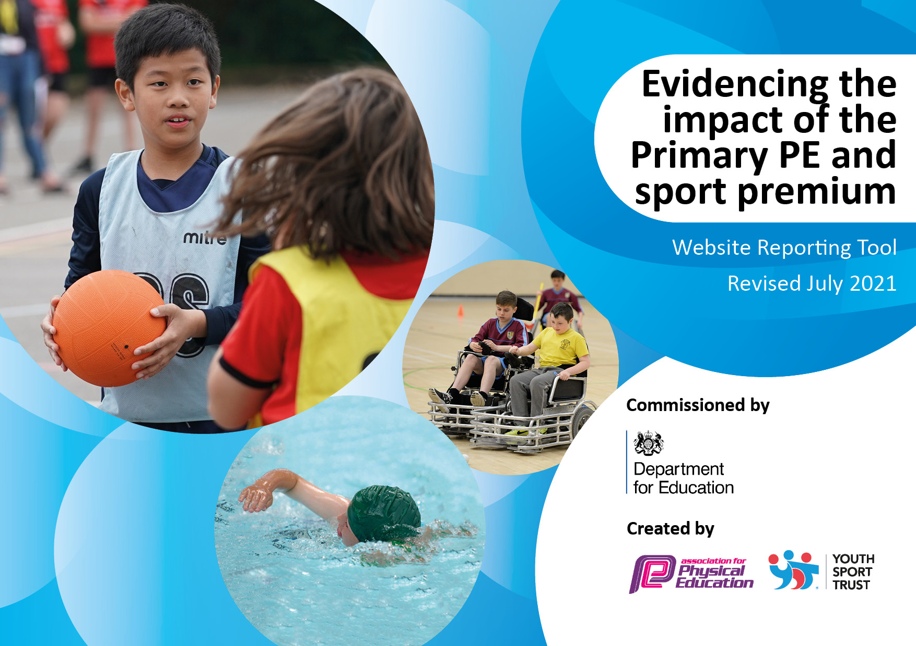
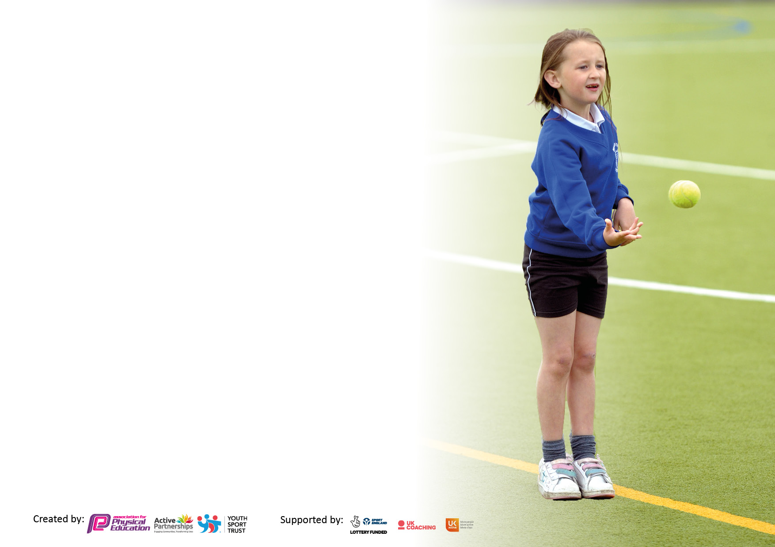

It is important that your grant is used effectively and based on school need. The Education Inspection Framework makes clear there will be a focus on ‘whether leaders and those responsible for governors all understand their respective roles and perform these in a way that enhances the effectiveness of the school’.

Under the Quality of Education Ofsted inspectors consider:
Intent - Curriculum design, coverage and appropriateness
Implementation - Curriculum delivery, Teaching (pedagogy) and Assessment
Impact - Attainment and progress

To assist schools with common transferable language this template has been developed to utilise the same three headings which should make your plans easily transferable between working documents.

Schools must use the funding to make additional and sustainable improvements to the quality of Physical Education, School Sport and Physical Activity (PESSPA) they offer. This means that you should use the Primary PE and sport premium to:

- Develop or add to the PESSPA activities that your school already offer
- Build capacity and capability within the school to ensure that improvements made now will benefit pupils joining the school in future years
- The Primary PE and sport premium should not be used to fund capital spend projects; the school’s budget should fund these.

Pleasevisitgov.ukfortherevisedDfEguidanceincludingthe5keyindicatorsacrosswhichschoolsshoulddemonstrate animprovement.Thisdocumentwillhelpyoutoreviewyourprovisionandtoreportyourspend.DfEencouragesschools to use this template as an effective way of meeting the reporting requirements of the Primary PE and sport premium.

We recommend you start by reflecting on the impact of current provision and reviewing the previous spend.

Schools are required to publish details of how they spend this funding, including any under-spend from 2019/2020, as well as on the impact it has on pupils’ PE and sport participation and attainment. All funding must be spent by 31st July 2022.

We recommend regularly updating the table and publishing it on your website throughout the year. This evidences your ongoing self-evaluation of how you are using the funding to secure maximum, sustainable impact. Final copy must be posted on your website by the end of the academic year and no later than the 31st July 2021. To see an example of how to complete the table please click HERE.
Created by: Supported by:

Details with regard to funding
Please complete the table below.

Total amount carried over from 2021/22 | £0
Total amount allocated for 2022/23 | £17,620
How much (if any) do you intend to carry over from this total fund into 2022/23? | £0
Total amount allocated for 2022/23 | £17620
Total amount of funding for 2022/23. To be spent and reported on by 31st July 2023. | £17620
Swimming Data
Please report on your Swimming Data below.

Meeting national curriculum requirements for swimming and water safety.

N.B. Complete this section to your best ability. For example you might have practised safe self-rescue techniques on dry land which you can then transfer to the pool when school swimming restarts.
Due to exceptional circumstances priority should be given to ensuring that pupils can perform safe self rescue even if they do not fully meet the first two requirements of the NC programme of study
What percentage of your current Year 6 cohort swim competently, confidently and proficiently over a distance of at least 25 metres?  N.B. Even though your pupils may swim in another year please report on their attainment on leaving primary school at the end of the summer term 2021.  Please see note above | %
What percentage of your current Year 6 cohort use a range of strokes effectively [for example, front crawl, backstroke and breaststroke]?  Please see note above | %
What percentage of your current Year 6 cohort perform safe self-rescue in different water-based situations? | %
Schools can choose to use the Primary PE and sport premium to provide additional provision for swimming but this must be for activity over and above the national curriculum requirements. Have you used it in this way? | Yes/No

Action Plan and Budget Tracking
Capture your intended annual spend against the 5 key indicators. Clarify the success criteria and evidence of impact that you intend to measure to evaluate for pupils today and for the future.

Academic Year: 2022/23 | Total fund allocated:17620 | Date Updated:
Key indicator 1: The engagement of all pupils in regular physical activity – Chief Medical Officers guidelines recommend that primary school pupils undertake at least 30 minutes of physical activity a day in school |  |  |  | Percentage of total allocation:
 |  |  |  | %
Intent | Implementation |  | Impact
Your school focus should be clear what you want the pupils to know and be able to do and about  what they need to learn and to  consolidate through practice: | Make sure your actions to achieve are linked to your intentions: | Funding allocated: | Evidence of impact: what do pupils now know and what can they now do? What has changed?: Impact in red - aims | Sustainability and suggested next steps:
Continue to develop outdoor environment with a focus EYFS range of equipment to engage pupils in physical activity – bikes/scooters, climbing, building, football, games  Exceed Government Guidelines on physical activity  Behaviour and social engagement to improve through more opportunities to engage in sporting activities at break and lunch. | - Purchase climbing resources for EYFS area  - Increase number of wheeled equipment  - Introduce Just Dance to morning break times  - Refresher training for staff due to change in personnel  - Introduce daily mile  To provide a range of after school clubs which encourage physical activity  ( Opal / forest school / KS1 football / Y3 / 4 footballs and Y5/6 football | £2500  £3000 | OPAL audit and action plan  Maintain OPAL platinum status  Maintain Gold School Games Mark  Achieve Gold Active Award  All children active over lunchtime and after school period (N-Y6)
Key indicator 2: The profile of PESSPA being raised across the school as a tool for whole school improvement |  |  |  | Percentage of total allocation:
 |  |  |  | %
Intent | Implementation |  | Impact
Your school focus should be clear what you want the pupils to know and be able to do and about  what they need to learn and to  consolidate through practice: | Make sure your actions to achieve are linked to your intentions: | Funding allocated: | Evidence of impact: what do pupils now know and what can they now do? What has changed?: | Sustainability and suggested next steps:
PE lead continue to undertake series of CPD in order to further develop provision and gain gold active mark award  PE scheme of work used across school with CPD for staff throughout the year from PE lead  Train pupils as sports leaders and develop their role across school | Attend CPD on accurate assessment  Evidence gathering to be submitted  PE lead and deliver training on assessment to all staff – consider recording of PE across school using Ipads  SAFC coach to train new Y5/6 pupils as sports leaders | £1000  £1000  £1000  £1000 | Accurate assessments and developmentals given  Pupils trained as sports leaders

Key indicator 3: Increased confidence, knowledge and skills of all staff in teaching PE and sport |  |  |  | Percentage of total allocation:
 |  |  |  | %
Intent | Implementation |  | Impact
Your school focus should be clear | Make sure your actions to | Funding | Evidence of impact: what do | Sustainability and suggested
what you want the pupils to know | achieve are linked to your | allocated: | pupils now know and what | next steps:
and be able to do and about | intentions: |  | can they now do? What has
what they need to learn and to |  |  | changed?:
consolidate through practice:
High quality swimming provision  All teachers to have a high level of subject knowledge  Staff work alongside PE coach to further develop their skills to deliver age appropriate PE lessons | - Dedication of highly qualified and experienced swimming coach to deliver sessions  - Staff cpd around accurate assessments  - Work alongside trained coaches  All KS2 pupils have at least one term swimming. Additional swimming given in year 6 for children not achieving milestones  Coaching and mentoring by SAFC | £1725  £4000 | Improved understanding of all staff in teaching PE  Increased percentages of children at age related expectations and above
Key indicator 4: Broader experience of a range of sports and activities offered to all pupils |  |  |  | %
Intent | Implementation |  | Impact
Your school focus should be clear | Make sure your actions to | Funding | Evidence of impact: what do | Sustainability and suggested
what you want the pupils to know | achieve are linked to your | allocated: | pupils now know and what | next steps:
and be able to do and about | intentions: |  | can they now do? What has
what they need to learn and to |  |  | changed?:
consolidate through practice:
In addition to planned PE sessions, we will offer a wide range of sports and activities including :- Football , cricket,skipping, tag rugby , dance, Boccia, Athletics, WISE Football World Cup | - Attend Sports Ability, Health and Well being festival, Leadership Festival, Change for Life Launch, Castle View talent identification sessions, Beacon of Light initiatives | £1000 | Children exposed to wide range of sporting activities and venues  Increase in sporting participation alongside increase in sporting achievements.

Key indicator 5: Increased participation in competitive sport |  |  |  | Percentage of total allocation:
 |  |  |  | %
Intent | Implementation |  | Impact
Your school focus should be clear | Make sure your actions to | Funding | Evidence of impact: what do | Sustainability and suggested
what you want the pupils to know | achieve are linked to your | allocated: | pupils now know and what | next steps:
and be able to do and about | intentions: |  | can they now do? What has
what they need to learn and to |  |  | changed?:
consolidate through practice:
In addition to planned PE sessions, we will offer a wide range of sports and activities including :- Football , cricket,skipping, tag rugby , dance, Boccia, Athletics, WISE Football World Cup  Sports day FS-Y6 | -Train weekly and attend matches / events during and after school with transport costs | £3500 | Increased participation in sorting events / activities to supplement the recommended daily physical activity.  Greater opportunities to try different activities

Signed off by
Head Teacher: | 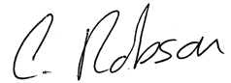
Date: | 13/9/23
Subject Leader: | S.Horn
Date: | 13/9/23
Governor:
Date:

