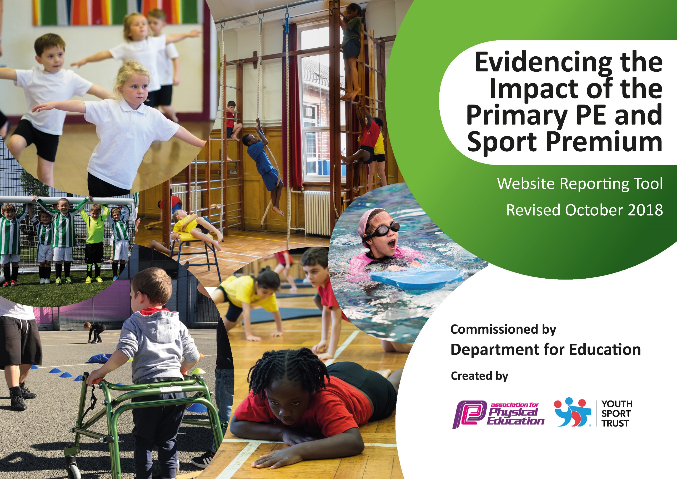
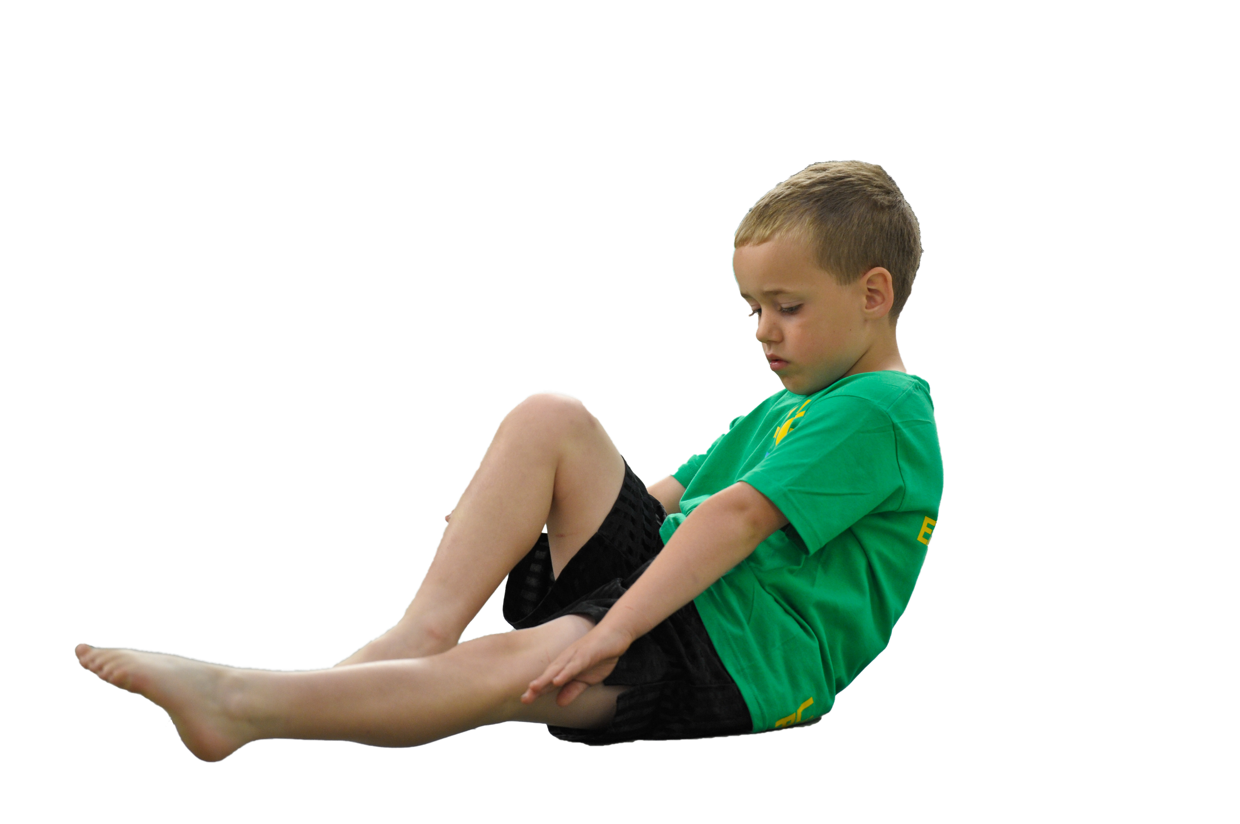
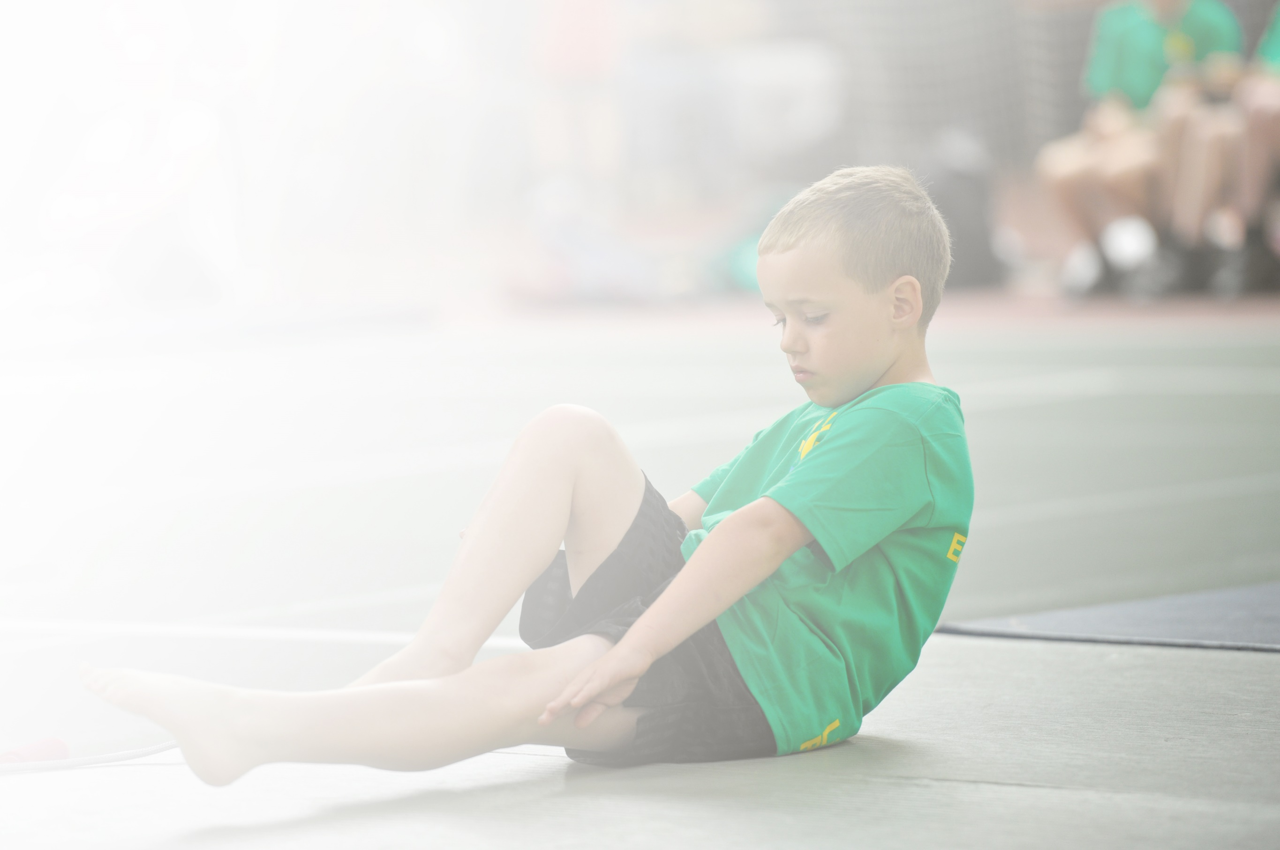
Schools must use the funding to make additional and sustainable improvements to the quality of Physical Education, Sport and Physical Activity (PESPA) they offer. This means that you should use the Primary PE and Sport Premium to:

- Develop or add to the PESPA activities that your school already offer
- Build capacity and capability within the school to ensure that improvements made now will benefit pupils joining the school in future years

Please visit gov.uk for the revised DfE guidance including the 5 key indicators across which schools should demonstrate an improvement. This document will help you to review your provision and to report
your spend. DfE encourages schools to use this template as an effective way of meeting the reporting requirements of the Primary PE and Sport Premium.

We recommend you start by reflecting on the impact of current provision and reviewing the previous
spend. Under the Ofsted Schools Inspection Framework, inspectors will assess how effectively leaders use the Primary PE and Sport Premium and measure its impact on outcomes for pupils, and how effectively governors hold them to account for this.

Schools are required to publish details of how they spend this funding as well as on the impact it has on pupils’ PE and sport participation and attainment by the end of the summer term or by 31 July 2020 at the
latest.
We recommend regularly updating the table and publishing it
on your website throughout the year, as evidence of your
ongoing review into how you are using the money to
secure maximum, sustainable impact. To see an
example of how to complete the table please
click HERE.

Support for review and reflection - considering the 5 key indicators from DfE, what development needs are a priority for your setting and your students now and why? Use the space below to reflect on previous spend, identify current need and priorities for the future.

Key achievements to date: | Areas for further improvement and baseline evidence of need:
Good range of PE offered across the year  Successful interschool skipping in year 4 and 2 (year 2 overall winners 2 years in a row)  All KS2 children access swimming over the year  Good links with secondary school provide range of PE activities to year 4, 5 and 6  OPAL platinum school for outdoor lunchtime provision  SAFC lunchtime and after school club weekly  Silver active mark achieved (19/20)  Third place in WISE games at Gateshead stadium  School football team in place  Y6 activity residential yearly | Increase staff knowledge and skills in all areas of PE  Provide a secure framework for teachers to plan and deliver outstanding PE lessons  Access for some children to the daily mile (intervention) but allow access for all

Meeting national curriculum requirements for swimming and water safety | Please complete all of the below:
What percentage of your current Year 6 cohort swim competently, confidently and proficiently over a distance of at least 25 metres?  N.B. Even though your children may swim in another year please report on their attainment on leaving  primary school. | (2018-2019 Y6 cohort, 2020/2021 cohort cut short due to COVID)  86%
What percentage of your current Year 6 cohort use a range of strokes effectively [for example, front crawl, backstroke and breaststroke]? | (2018-2019 Y6 cohort, 2020/2021 cohort cut short due to COVID )  86%
What percentage of your current Year 6 cohort perform safe self-rescue in different water-based situations? | (2018-2019 Y6 cohort, 2020/2021 cohort cut short due to COVID )  86%
Schools can choose to use the Primary PE and Sport Premium to provide additional provision for swimming but this must be for activity over and above the national curriculum requirements. Have you used it in this way? | No

Action Plan and Budget Tracking
Capture your intended annual spend against the 5 key indicators. Clarify the success criteria and evidence of impact that you intend to measure to evaluate for students today and for the future.

Academic Year: 2021/22 | Total fund allocated: £17,890 | Date Updated: September 2021
Key indicator 1: The engagement of all pupils in regular physical activity – Chief Medical Officer guidelines recommend that primary school children undertake at least 30 minutes of physical activity a day in school |  |  |  | Percentage of total allocation:
 |  |  |  | 41%
Intention | Implementation |  | Impact
School focus with clarity on intended impact on pupils: | Actions to achieve: | Funding allocated: | Intended Evidence to be gathered to demonstrate impact: | Sustainability and suggested next steps:
Continue to develop outdoor environment with range of equipment to engage pupils in physical activity – bikes/scooters, climbing, building, football, games  Additional TA at lunchtime to encourage active playground | OPAL audit (Nov 21) and action plan to develop active learning outdoors  Lunchtime supervisor responsible for leading sport activities | £4000  £2000 | OPAL audit and action plan  Maintain OPAL platinum status  All children active over lunchtime period (N-Y6)
Key indicator 2: The profile of PESSPA being raised across the school as a tool for whole school improvement |  |  |  | Percentage of total allocation:
 |  |  |  | 12%
Intention | Implementation |  | Impact
School focus with clarity on intended impact on pupils: | Actions to achieve: | Funding allocated: | Intended Evidence to be gathered to demonstrate impact: | Sustainability and suggested next steps:
PE lead undertake series of CPD in order to further develop provision and gain gold active mark award  PE scheme of work used across school with CPD for staff throughout the year from PE lead  Train pupils as sports leaders and develop their role across school | Attend CPD  Evidence gathering to be submitted  PE lead and deliver training to all staff – consider recording of PE across school using Ipads  PE lead and Y5/6 pupils access training | £1000  £1000  £1000 | Gold active mark achieved May 2021  Consistent and progressive PE across school  Pupils trained as sports leaders

Key indicator 3: Increased confidence, knowledge and skills of all staff in teaching PE and sport |  |  |  | Percentage of total allocation:
 |  |  |  | 29%
Intention | Implementation |  | Impact
School focus with clarity on intended  impact on pupils: | Actions to achieve: | Funding  allocated: | Intended Evidence to be gathered to demonstrate impact: | Sustainability and suggested  next steps:
Ta responsible for taking children swimming is qualified coach and supports with teaching groups at swimming  Staff work alongside PE coach to further develop their skills to deliver age appropriate PE lessons | Qualification achieved so more pupils get access to swimming  All KS2 pupils have at least one term swimming. Additional swimming given in year 6 for children not achieving milestones  Coaching and mentoring by SAFC | £1000  £1000  £2850 | 100% of Y6 pupils can achieve the standards set out in the guidance – 100% swim 25m, use range of stokes and self save  Improved understanding of all staff in teaching PE  As a result of good leadership in the subject and confident and knowledgeable staff, all pupils made good or better progress, building on prior achievement.
Key indicator 4: Broader experience of a range of sports and activities offered to all pupils |  |  |  | Percentage of total allocation:
 |  |  |  | 6%
Intention | Implementation |  | Impact
School focus with clarity on intended  impact on pupils: | Actions to achieve: | Funding  allocated: | Intended Evidence to be gathered to demonstrate impact: | Sustainability and suggested  next steps:
Y2 and Y4 take part in inter schools skipping competition | TA’s trained to teach skipping  Skipping coach delivers skipping programme to year 2 and 4  Weekly skipping lessons and after school clubs | 1 term TA 1 hour per week x2  Costs of training and transport  £1000 | Full attendance at weekly skipping lessons  Y2 and 4 compete alongside other schools in competition summer term
Key indicator 5: Increased participation in competitive sport |  |  |  | Percentage of total allocation:
 |  |  |  | 15%
Intention | Implementation |  | Impact
School focus with clarity on intended  impact on pupils: | Actions to achieve: | Funding  allocated: | Evidence and impact: | Sustainability and suggested  next steps:
KS2 football team  Sports day FS-Y6  Charity fund raiser – Wipeout (summer term)  Termly access to courses ran by foundation of light – all year groups (range of activities) | Train weekly and attend matches after school with transport costs  All year groups have access to ‘Foundation of light’ courses throughout the year (see additional plan) with transport costs | £1000  £500  £1000 | Football team attend matches  Parent/pupil voice from sports day  Participation figures for wipeout event and analysis of funds raised  Staff feedback re participation of pupils and quality of courses – evidence documented using Ipad

